Annual Quality Assurance Report (AQAR)
(Revised in October 2013)

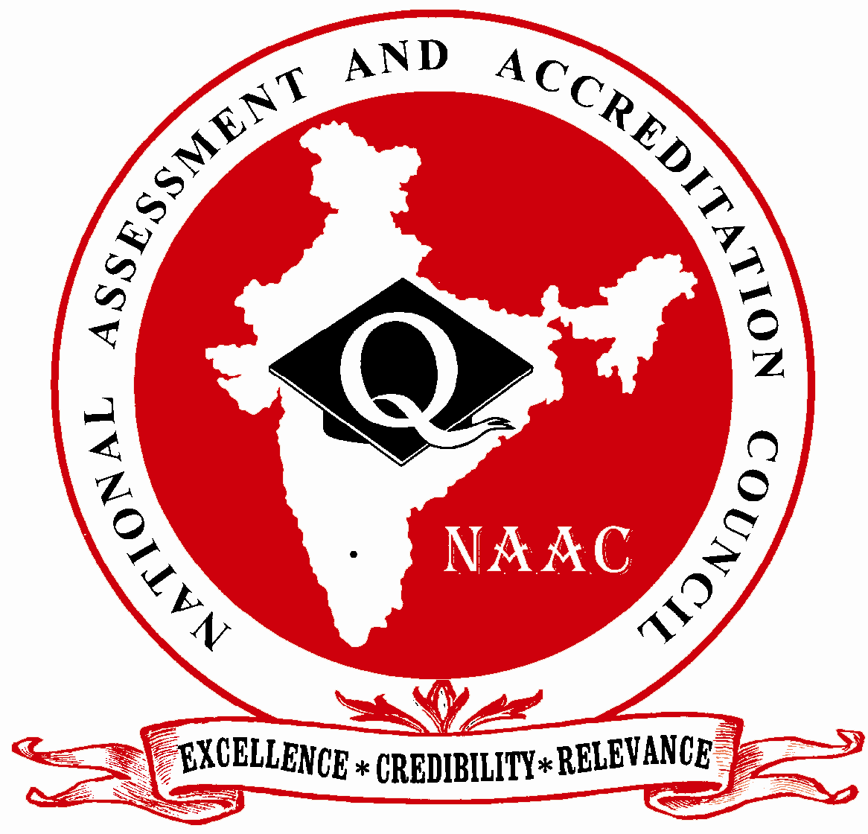

NATIONAL ASSESSMENT AND ACCREDITATION COUNCIL
An Autonomous Institution of the University Grants Commission
P. O. Box. No. 1075, Opp: NLSIU, Nagarbhavi, Bangalore - 560 072 India

Note:
The NAAC Accredited institutions need to submit only the soft copy as word file (.doc/.docx) through e-mail (naac.aqar@gmail.com). The file name needs to be submitted with Track ID of the institution and College Name. For example MHCOGN16601-Samudra Arts and Science College, Taliamegu-Maharashtra.doc or EC_32_A&A_143 dated 3-5-2004-Samudra Arts and Science College, Taliamegu-Maharashtra.doc. The Higher Education Institutions need not submit the printed/hard copy to NAAC. The acknowledgements would be sent to the institutions through e-mail.

The Annual Quality Assurance Report (AQAR) of the IQAC

All NAAC accredited institutions will submit an annual self-reviewed progress report to NAAC, through its IQAC. The report is to detail the tangible results achieved in key areas, specifically identified by the institutional IQAC at the beginning of the academic year. The AQAR will detail the results of the perspective plan worked out by the IQAC. (Note: The AQAR period would be the Academic Year. For example, July 1, 2012 to June 30, 2013)

Part – A
2013-14
AQAR for the year (for example 2013-14)

1. Details of the Institution
Rajdhani College Bhubaneswar

1.1 Name of the Institution
BARAMUNDA
1.2 Address Line 1
BHUBANESWAR
Address Line 2
BHUBANESWAR
City/Town
ODISHA
State
751003
Pin Code
rajdhanicollege@yahoo.in
Institution e-mail address
06742562491
Contact Nos.
DR. GEETIKA PATTANAIK
Name of the Head of the Institution:
06742562491

Tel. No. with STD Code:
+919437002592
Mobile:
DR. PRANAB MANGARAJ
Name of the IQAC Co-ordinator:
09777918800
Mobile:
iqacrajdhani@gmail.com
IQAC e-mail address:

ORCOGN12763
1.3 NAAC Track ID (For ex. MHCOGN 18879)
OR

1.4 NAAC Executive Committee No. & Date:
EC/39/64 dated 21-5-2006
(For Example EC/32/A&A/143 dated 3-5-2004.
This EC no. is available in the right corner- bottom
of your institution’s Accreditation Certificate)

www.rajdhanicollege.co.in
1.5 Website address:
www.rajdhanicollege.org.in/AQAR2013-14.doc
Web-link of the AQAR:
For ex. http://www.ladykeanecollege.edu.in/AQAR2012-13.doc
1.6 Accreditation Details
Sl. No. | Cycle | Grade | CGPA | Year of Accreditation | Validity Period
1 | 1st Cycle | B+ | 75.30 | 2006 | 5yrs w.e.f. 21.05.2006
2 | 2nd Cycle | LOI submitted on 24.09.14
3 | 3rd Cycle
4 | 4th Cycle

1.7 Date of Establishment of IQAC : DD/MM/YYYY
02/04/2014

1.8 Details of the previous year’s AQAR submitted to NAAC after the latest Assessment and Accreditation by NAAC ((for example AQAR 2010-11submitted to NAAC on 12-10-2011)
i. AQAR Hard copy version submitted on 23/06/14(DD/MM/YYYY)
ii. AQAR Submitted on line on July 2,2015 (02/07/2015)
iii. AQAR__________________ _______________________ (DD/MM/YYYY)
iv. AQAR__________________ _______________________ (DD/MM/YYYY)
1.9 Institutional Status

University State Central Deemed Private
√

Affiliated College Yes No
Constituent College Yes No

Autonomous college of UGC Yes No

Regulatory Agency approved Institution Yes No
(e.g. AICTE, BCI, MCI, PCI, NCI)
√

Type of Institution Co-education Men Women

Urban Rural Tribal

√

√

Financial Status Grant-in-aid UGC 2(f) UGC 12B

Grant-in-aid + Self Financing Totally Self-financing

1.10 Type of Faculty/Programme
√

√

√

Arts Science Commerce Law PEI (Phys Edu)

TEI (Edu) Engineering Health Science Management

Others (Specify)

1.11 Name of the Affiliating University (for the Colleges)
UTKAL UNIVERSITY, BHUBANESWAR

1.12 Special status conferred by Central/ State Government-- UGC/CSIR/DST/DBT/ICMR etc
N. A.
Autonomy by State/Central Govt. / University

University with Potential for Excellence UGC-CPE

DST Star Scheme UGC-CE

UGC-Special Assistance Programme DST-FIST

UGC-Innovative PG programmes Any other (Specify)

UGC-COP Programmes
2. IQAC Composition and Activities
07
2.1 No. of Teachers
02
2.2 No. of Administrative/Technical staff
NIL
2.3 No. of students
2.4 No. of Management representatives
NIL
01
2.5 No. of Alumni
2. 6 No. of any other stakeholder and
NIL
community representatives
NIL
2.7 No. of Employers/ Industrialists

2.8 No. of other External Experts
01
2.9 Total No. of members
09
2.10 No. of IQAC meetings held ELEVEN
NIL
05
2.11 No. of meetings with various stakeholders: No. Faculty
NIL
NIL
NIL
Non-Teaching Staff Students Alumni Others
√

2.12 Has IQAC received any funding from UGC during the year? Yes No √

If yes, mention the amount
2.13 Seminars and Conferences (only quality related)
(i) No. of Seminars/Conferences/ Workshops/Symposia organized by the IQAC
2

2
Total Nos. International National State Institution Level
- Secularism in India 2. Political Elites of India.
india 2.Political Elites in India
(ii) Themes
2.14 Significant Activities and contributions made by IQAC
1. Website was updated. 2.Utilization Certificates of UGC Funds received during the XI Plan, pending for some time, were submitted.3.Internal Quality Sustenance and Development Survey Report was submitted on line. 4. Heads of Departments submitted a tentative Seminar Schedule for the academic year ahead at the beginning of the session and tried to implement that to the maximum extent. 5. Planning Board was set up for deciding upon policy initiatives.6. Setting up of Degree Laboratories for +3 Science students was taken up by the Authority on priority basis.

2.15 Plan of Action by IQAC/Outcome
The plan of action chalked out by the IQAC in the beginning of the year towards quality
enhancement and the outcome achieved by the end of the year *

Plan of Action | Achievements
Routine Academic Audit  Library Services for students, teachers & researchers.  Permanent University Affiliation for all courses and seats as on date.  Infrastructure development in general and Science laboratories in particular | Activity cum Progress Registers of the Faculty , Tabulation Registers and Seminar Registers of departments are being checked by the Principal at regular intervals.  Reading Room Facility is now available throughout the year except on holidays/vacations.  IQAC pursued the work of securing permanent university affiliation for all the UG & PG courses which commenced from 2013-14 successfully.  Construction of a New Block which was underway was expedited with the pleadings of the cell to accommodate the huge number of classes added to the existing ones. Ladies Hostel construction was also speeded up the same way.  Two big halls ( U-1 & U- 4 ) were earmarked as Chemistry and Physics Laboratories respectively and developed subsequently.
* Attach the Academic Calendar of the year as Annexure.

√

2.15 Whether the AQAR was placed in statutory body Yes No

Management Syndicate Any other body
Provide the details of the action taken
Action was initiated for the reconstitution of the Governing Body which remained non-functional for years.

Part – B
Criterion – I

1. Curricular Aspects

1.1 Details about Academic Programmes
Level of the Programme | Number of existing Programmes | Number of programmes added during the year | Number of self-financing programmes | Number of value added / Career Oriented programmes
PhD
PG | 01 | 01  PG in ODIA | 01 | 01(PGDCA offered by JVCC)
UG | 17 | 07
PG Diploma
Advanced Diploma
Diploma
Certificate
Others
Total | 18

Interdisciplinary
Innovative

1.2 (i) Flexibility of the Curriculum: CBCS/Core/Elective option / Open options Elective Option
(ii) Pattern of programmes:
Pattern | Number of programmes
Semester | 01
Trimester
Annual | 17

√

√

1.3 Feedback from stakeholders* Alumni Parents Employers Students
(On all aspects)

√

Mode of feedback : Online Manual Co-operating schools (for PEI)
*Please provide an analysis of the feedback in the Annexure

1.4 Whether there is any revision/update of regulation or syllabi, if yes, mention their salient aspects.
The college follows the syllabi prescribed by the University.

1.5 Any new Department/Centre introduced during the year. If yes, give details.
Year 2013-14 was a watershed year in this respect. Govt. permission was accorded for opening PG Course in Odia ,UG Honours courses in Six science subjects ;Physics, Chemistry, Mathematics, Botany, Zoology & Geology and Two Commerce subjects; Accountancy and Management. Except the newly opened PG Deptt.,all the departments became functional from the session 13-14.
ccourses

Criterion – II
2. Teaching, Learning and Evaluation
2.1 Total No. of permanent faculty
Total | Asst. Professors | Associate Professors | Professors | Others
42 | 13 | 24 |  | 05 Demonstrators
21
2.2 No. of permanent faculty with Ph.D.
2.3 No. of Faculty Positions Recruited (R) and Vacant (V) during the year
Asst. Professors |  | Associate Professors |  | Professors |  | Others |  | Total
R | V | R | V | R | V | R | V | R | V
Only Guest Faculty are recruited by the college.
2.4 No. of Guest and Visiting faculty and Temporary faculty - 21(Twenty One) Guest Faculty
21

2.5 Faculty participation in conferences and symposia:

No. of Faculty | International level | National level | State level
Attended Seminars/ Workshops |  | 07
Presented papers |  | 02 | 01
Resource Persons |  |  | 01

2.6 Innovative processes adopted by the institution in Teaching and Learning:
- Time Table provides for a weekly seminar in all subjects.2. Observance of important days (Recognised by Central Govt., State Govt. and the U.N.O) related to our culture and literature. 3. Audio-visual methods are employed by selected departments. 4. Guest Lecture Programmes are frequently conducted by the departments. 5. Supplementing syllabus oriented studies with different forms of social activities.

180
2.7 Total No. of actual teaching days
during this academic year
As per the pattern prescribed by the University. At the college level, there is provision for monthly class tests, pre-test & Half Yearly examinations.
2.8 Examination/ Evaluation Reforms initiated by
the Institution (for example: Open Book Examination, Bar Coding,
Double Valuation, Photocopy, Online Multiple Choice Questions)

07

2.9 No. of faculty members involved in curriculum
restructuring/revision/syllabus development
as member of Board of Study/Faculty/Curriculum Development workshop
Above 85
2.10 Average percentage of attendance of students

2.11 Course/Programme wise
distribution of pass percentage :

Title of the Programme | Total no. of students appeared | Division
Title of the Programme | Total no. of students appeared | Distinction % | I % | II % | III % | Pass %
+3 3rd yr | 217 |  | 48 |  |  | 80.18
+3 2nd yr | 235 |  |  |  |  | 83.4
+3 1st yr | 483 |  |  |  |  | 45.13

2.12 How does IQAC Contribute/Monitor/Evaluate the Teaching & Learning processes :
Following steps have been taken by IQAC to contribute to teaching & learning process. 1.Introduction of Annual Academic Calendar from 2013-14 2.Strict Academic Audit from 2013-14 3.Infrastructure Development especially setting up of Laboratories for +3Science students 4. Campus Development through voluntary initiatives of students 5.Better Library Services like availability of reading Room Facility on all working days 6.Subscription of Professional journals in all subjects to promote the research climate 7.Xeroxing (of reading materials) facility for all library users 8.Provision of Question Banks for students in the respective departments 9.Planning of Seminar Activities by Heads of Departments at the beginning of the academic year .
2.13 Initiatives undertaken towards faculty development
Faculty / Staff Development Programmes | Number of faculty  benefitted
Refresher courses | 02
UGC – Faculty Improvement Programme | Nil
HRD programmes | 02
Orientation programmes | 01
Faculty exchange programme | Nil
Staff training conducted by the university | Nil
Staff training conducted by other institutions | 02
Summer / Winter schools, Workshops, etc. | Nil
Others | Students of YRC and NSS attended training camps organised by State Youth RedCross Society, Odisha NSS respectively.
2.14 Details of Administrative and Technical staff
Category | Number of Permanent  Employees | Number of Vacant  Positions | Number of permanent positions filled during the Year | Number of positions filled temporarily
Administrative Staff | 22 | 05
Technical Staff | 15 | 07 |  | 01
Criterion – III
3. Research, Consultancy and Extension
3.1 Initiatives of the IQAC in Sensitizing/Promoting Research Climate in the institution
Library computerisation, Initiative taken for Subscription of Professional journals in all subjects by the College library to promote the research climate and Xeroxing facility for all library users are some of the cell’s achievements in this regard.

3.2 Details regarding major projects: Not Applicable
 | Completed | Ongoing | Sanctioned | Submitted
Number
Outlay in Rs. Lakhs

3.3 Details regarding minor projects: Not Applicable
 | Completed | Ongoing | Sanctioned | Submitted
Number
Outlay in Rs. Lakhs

3.4 Details on research publications:
 | International | National | Others
Peer Review Journals |  | 02
Non-Peer Review Journals |  |  | 05
e-Journals |  |  | Nil
Conference proceedings |  |  | 03

3.5 Details on Impact factor of publications: Not Available

Range Average h-index Nos. in SCOPUS
3.6 Research funds sanctioned and received from various funding agencies, industry and other organisations
Nature of the Project | Duration  Year | Name of the  funding Agency | Total grant  sanctioned | Received
Major projects
Minor Projects
Interdisciplinary Projects
Industry sponsored
Projects sponsored by the University/ College
Students research projects
(other than compulsory by the University)
Any other(Specify)
Total
Nil

3.7 No. of books published i) With ISBN No. Chapters in Edited Books
15
01
03
ii) Without ISBN No.
3.8 No. of University Departments receiving funds from Not Applicable
UGC-SAP CAS DST-FIST

DPE DBT Scheme/funds
3.9 For colleges Autonomy CPE DBT Star Scheme

INSPIRE CE Any Other (specify)

Nil
3.10 Revenue generated through consultancy
Level | International | National | State | University | College
Number |  |  |  |  | 02
Sponsoring agencies
3.11 No. of conferences
organized by the Institution
02
3.12 No. of faculty served as experts, chairpersons or resource persons

Local
3.13 No. of collaborations International National Any other
02
3.14 No. of linkages created during this year
3.15 Total budget for research for current year in lakhs :

From Funding agency From Management of University/College
Total
Nil

3.16 No. of patents received this year
Type of Patent |  | Number
National | Applied
National | Granted
International | Applied
International | Granted
Commercialised | Applied
Commercialised | Granted
Nil

3.17 No. of research awards/ recognitions received by faculty and research fellows
Of the institute in the year: NIL
Total | International | National | State | University | Dist | College

3.18 No. of faculty from the Institution
07
who are Ph. D. Guides
and students registered under them
11

3.19 No. of Ph.D. awarded by faculty from the Institution
05

3.20 No. of Research scholars receiving the Fellowships (Newly enrolled + existing ones) Nil

JRF SRF Project Fellows Any other

3.21 No. of students Participated in NSS events:

45
University level State level
National level International level

3.22 No. of students participated in NCC events:

50
University level State level
National level International level
02

3.23 No. of Awards won in NSS: Nil
University level State level

National level International level

3.24 No. of Awards won in NCC:
University level State level

National level International level
02

3.25 No. of Extension activities organized

15
University forum College forum
05

10 blood donation camps held by the YRC Unit
NCC NSS Any other

3.26 Major Activities during the year in the sphere of extension activities and Institutional Social Responsibility
- Extension Activities and Social Initiatives: The YRC Unit of the College organized a record number of Blood Donation Camps during 2013-14.
- Campaigns to promote Road-safety awareness, Campaigns against Addiction, Various Plantation Drives, to name only a few, were also undertaken by students under the direct supervision of Officers-in-charge, N.C.C. , YRC & N.S.S .

Criterion – IV
4. Infrastructure and Learning Resources
4.1 Details of increase in infrastructure facilities:
Facilities | Existing | Newly created | Source of Fund | Total
Campus area | 15 acres | Nil | Govt. | 15 acres
Class rooms | 32 | 03 |  | 35
Laboratories | 05 | nil |  | 05
Seminar Halls | 01 | nil |  | 01
No. of important equipments purchased (≥ 1-0 lakh) during the current year.
Value of the equipment purchased during the year (Rs. in Lakhs)
Others

4.2 Computerization of administration and library
Desk tops have been provided for the Academic and Accounts desks. Library computerisation is almost complete.

4.3 Library services:
 | Existing |  | Newly added |  | Total
 | No. | Value | No. | Value | No. | Value
Text Books |  |  |  |  | 26834
Reference Books |  |  |  |  | 4075
e-Books |  |  |  |  | 03
Journals
e-Journals
Digital Database
CD & Video |  |  |  |  | 15
Others (specify)

4.4 Technology up gradation (overall)
 | Total Computers | Computer Labs | Internet | Browsing Centres | Computer Centres | Office | Depart-ments | Others
Existing | 15 | 01 | 01 | 01 |  | 05 |  | 02 computers in the lib
Added | nil | Nil | nil | Nil |  | Nil
Total | 15

4.5 Computer, Internet access, training to teachers and students and any other programme for technology
upgradation (Networking, e-Governance etc.)
Internet access facility is provided to the teachers in the IT Lab of the college.

4.6 Amount spent on maintenance in lakhs :
1,94,107
i) ICT
35,285
ii) Campus Infrastructure and facilities
12,143
iii) Equipments
81,250
iv) Others

3,22,785
Total :

Criterion – V
5. Student Support and Progression
5.1 Contribution of IQAC in enhancing awareness about Student Support Services
Provision of Question Banks, Regular Assistance to the Career Counselling & Placement Cell in organizing Counselling Sessions by professional agencies and prospective employers.
7 Placement Ce

5.2 Efforts made by the institution for tracking the progression
As there was no mechanism available , IQAC is trying to create one cell to address the progression/switch-over issue.

5.3 (a) Total Number of students
UG | PG | Ph. D. | Others
1034 | 16 | Nil | Nil

(b) No. of students outside the state
Nil
Nil
(c) No. of international students

Men Women
No | %
472 | 45
No | %
578 | 55
Last Year |  |  |  |  |  | This Year
General | SC | ST | OBC | Physically Challenged | Total | General | SC | ST | OBC | Physically Challenged | Total
537 | 127 | 141 |  |  | 805 | 824 | 120 | 116 | - | - | 1050
Demand ratio 100% Dropout % Negligible
5.4 Details of student support mechanism for coaching for competitive examinations (If any):
Currently, there is none. However, efforts are being made to provide for coaching facility for competitive examinations in the near future.
√
√
√

No. of students beneficiaries
5.5 No. of students qualified in these examinations: NIL

NET SET/SLET GATE CAT
IAS/IPS etc State PSC UPSC Others

5.6 Details of student counselling and career guidance
Initiatives in this area were, unfortunately, negligible.

No. of students benefitted
Nil

5.7 Details of campus placement
On campus |  |  | Off Campus
Number of Organizations Visited | Number of Students Participated | Number of Students Placed | Number of Students Placed

5.8 Details of gender sensitization programmes : Nil

5.9 Students Activities
5.9.1 No. of students participated in Sports, Games and other events
951055

State/ University level National level International level

No. of students participated in cultural events
05

State/ University level National level International level

5.9.2 No. of medals /awards won by students in Sports, Games and other events
01

01
Sports : State/ University level National level International level
02

Cultural: State/ University level National level International level

5.10 Scholarships and Financial Support
 | Number of  Students | Amount
Financial support from institution
Financial support from government | 252 | Rs1,55,548
Financial support from other sources
Number of students who received International/ National recognitions

5.11 Student organised / initiatives

Fairs : State/ University level National level International level
01

Exhibition: State/ University level National level International level
10
5.12 No. of social initiatives undertaken by the students

5.13 Major grievances of students (if any) redressed: _During 13-14, no grievance has been registered. _____________________________________

Criterion – VI
6. Governance, Leadership and Management
6.1 State the Vision and Mission of the institution
VISION: OUR COLLEGE SEEKS TO UPHOLD AND SPREAD THE VALUES OF SPIRIT OF INQUIRY, PURSUIT OF EXCELLENCE AND HUMANISM AMONG ITS STUDENTS DRAWN FROM THE BROADEST CROSS SECTION OF SOCIETY REFLECTING THE INSTITUTIONAL GOALS OF EQUITY,ACCESS AND JUSTICE UNDER THE GUIDANCE OF ITS DEDICATED BAND OF FACULTY IN AN ENVIRONMENT CONGENIAL FOR EXPERIMENT,INNOVATION AND PROGRESS
.MISSION: OUR MISSION IS To elevate the college to an autonomous college during the 12th plan period, To make it a premier institution of higher education at the Under-Graduation level with potential for excellence and with provision for counseling and guidance for meaningful placements.

6.2 Does the Institution has a management Information System
College has plans to create one.

6.3 Quality improvement strategies adopted by the institution for each of the following:

6.3.1 Curriculum Development
Being an affiliated college of the university, the college abides by the curricula prescribed by the university. However, the college is now aiming to elevate itself to autonomous college and submitted an Institutional Development Plan to the Ministry of Human Resources Development , Govt. of India, in this regard. Achieving autonomy will, hopefully, provide ample room for experiment and innovation in curriculum design and teaching methods.

6.3.2 Teaching and Learning
- Audio- visual teaching aids are employed but, on a limited scale.
- Sufficient encouragement is provided for interactive type of classes with focus on inter-disciplinary approach.
- Provision for remedial classes is being extended to the relatively disadvantaged groups of students.
- Tentative seminar agenda of different departments have been planned for the ensuing session (2014-15) to ensure highly animated environment for the students on a day to day basis.
- Paper presentation, guest lectures, seminars, workshop etc, are organised throughout the year.
- Most of the seminars organized by Departments in the Arts stream are interdisciplinary in nature.
- There is provision for Routine Academic Audit of Lesson Plan and Progress Registers.
- Implementation of Annual Seminar Agenda is strictly adhered to.

6.3.3 Examination and Evaluation
Examinations are conducted as per Utkal University norms. However, the college also conduct its own periodic and Monthly tests, Pretest, Half Yearly and Annual Examinations(in certain cases).

.

6.3.4 Research and Development
IQAC has recommended subscription of research journals in each subject by the college library. It has also recommended organisation of guest lectures by subject experts to acquaint students and teachers with the recent advances made in different disciplines.

6.3.5 Library, ICT and physical infrastructure / instrumentation
Library computerisation has been completed.

6.3.6 Human Resource Management
No concerted effort has been made in this area during the year 13-14

6.3.7 Faculty and Staff recruitment
Most of the faculty are regular and permanent. Shortage of the teaching staff caused due to existing vacancies has been made good through recruitment of Guest Faculty depending on the workload of departments and as a temporary arrangement. During the session 2013-14, as many as 14 Guest Faculty were recruited for the +3 classes and
7 Guest Faculty for the +2 classes.

6.3.8 Industry Interaction / Collaboration
Institute has not collaborated with any industry so far.

6.3.9 Admission of Students
Admission process is predominantly an On-Line and Centralized process, monitored by the Department of Higher Education, Govt. Of Odisha.

6.4 Welfare schemes for
Teaching | Nil
Non teaching | Nil
Students | Facilities like Cycle stand, Canteen, Drinking water facility  Common rooms for boys and girls are available.  There is provision for Financial Assistance from SSG,SAF & Merit Scholarship too.

6.5 Total corpus fund generated
NIL

√
- √
- monitored 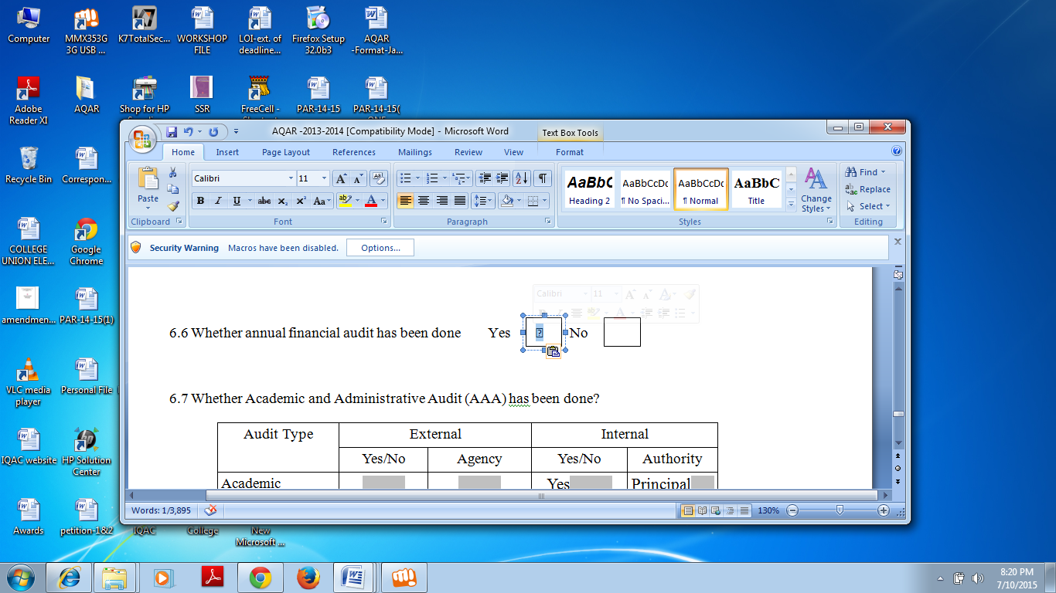

6.6 Whether annual financial audit has been done Yes No

6.7 Whether Academic and Administrative Audit (AAA) has been done?
Audit Type | External |  | Internal
Audit Type | Yes/No | Agency | Yes/No | Authority
Academic | Yes | DHE, Odisha | Yes | Principal
Administrative |  |  | Yes | Principal

6.8 Does the University/ Autonomous College declares results within 30 days?
√
For UG Programmes Yes No

For PG Programmes Yes No
√

6.9 What efforts are made by the University/ Autonomous College for Examination Reforms?
Being an affiliated college, the college fully abides by the pattern prescribed by the university.

6.10 What efforts are made by the University to promote autonomy in the affiliated/constituent colleges?
University holds Principals’ conferences from time to time to deliberate upon the UGC proposals and schemes related to academic decentralization in the higher education Institutions. It also convenes Boards of Studies meetings to discuss and approve UGC proposals in regard to curriculum development.

6.11 Activities and support from the Alumni Association
The college is trying to revive its Alumni association which had become defunct for sometime.

6.12 Activities and support from the Parent – Teacher Association
Sincere efforts are being made to make parent-Teacher interactions more frequent.

6.13 Development programmes for support staff
Support staff is encouraged to attend various training programmes organised by Govt. agencies and institutions from time to time.

6.14 Initiatives taken by the institution to make the campus eco-friendly
Observance of plantation week from July 1 to July 7, every year/preparation and use of Compost pits/Campus cleaning by NSS/NCC volunteers etc

Criterion – VII
7. Innovations and Best Practices
7.1 Innovations introduced during this academic year which have created a positive impact on the
functioning of the institution. Give details.
Submission of Annual Seminar Agenda at the beginning of the year & Introduction of Guest Lecture Programme from 2013-14 kept the academic environment vibrant.

7.2 Provide the Action Taken Report (ATR) based on the plan of action decided upon at the
beginning of the year
IQA Cell was formed as per NAAC guidelines. Website of the college was renewed and updated. Reaccreditation-related initiatives were pursued in right earnest. Infrastructure development was taken up on a war footing.

7.3 Give two Best Practices of the institution (please see the format in the NAAC Self-study Manuals)
- Keeping the Campus Clean and Green.
- Organisation of Blood Donation Camps at regular intervals.

*Provide the details in annexure (annexure need to be numbered as i, ii,iii)
7.4 Contribution to environmental awareness / protection
Science and Environment Society conducts seminars on environment related themes at periodic intervals.

√

7.5 Whether environmental audit was conducted? Yes No

7.6 Any other relevant information the institution wishes to add. (for example SWOT Analysis)
With the opening of science stream at the UG level in subjects like Physics, Chemistry, zoology, Mathematics, Botany, Geology from the session 2013-14, the college has become a full-fledged degree college. Ever-increasing demand for Commerce subjects like Accountancy, Management has led to a significant increase in the sanctioned strength of B.COM Honours classes from the current session. In the Arts stream, PG teaching facility is now available in two subjects; (1) Education and (2) Odia with the launching of M.A. Programme in Odia from 2013-14. The college already has provision for Honours teaching in most of the Arts subjects.

8. Plans of institution for next year
- To Set up Degree Labs for all the Science subjects
- To Provide residential facility for the out- station girl students of the college
- To Create An well-equipped Language Lab
- To create a Smart Room for hosting major programmes of the college.

Name __DR.PRANAB MANGARAJ Name DR.JAHAN ARA BEGUM


_______________________________ __________________________
Signature of the Coordinator, IQAC Signature of the Chairperson, IQAC

_______***_______

Annexure I
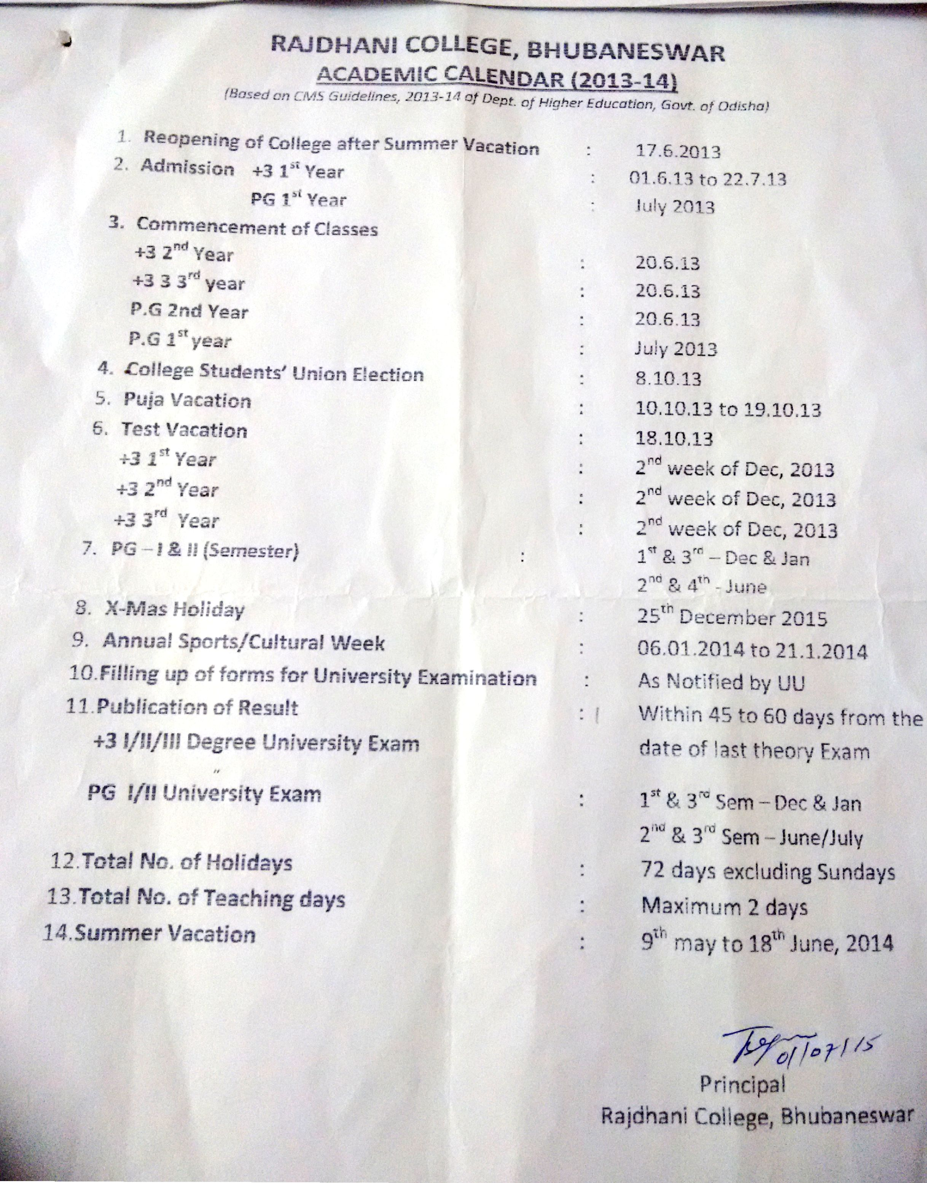

Abbreviations:
CAS - Career Advanced Scheme
CAT - Common Admission Test
CBCS - Choice Based Credit System
CE - Centre for Excellence
COP - Career Oriented Programme
CPE - College with Potential for Excellence
DPE - Department with Potential for Excellence
GATE - Graduate Aptitude Test
NET - National Eligibility Test
PEI - Physical Education Institution
SAP - Special Assistance Programme
SF - Self Financing
SLET - State Level Eligibility Test
TEI - Teacher Education Institution
UPE - University with Potential Excellence
UPSC - Union Public Service Commission

***************

